React Native Expo Project
Progress Log
Student Name: ____Katellyn Hyker____________________________________
App Name: ______InnerBloom__________________________________

Progress Made

Finished handling user signup/login and connected to database properly
Adjusted Entries and Habits to be user specific
Design Updates
Include screenshots or images of your app screens below.
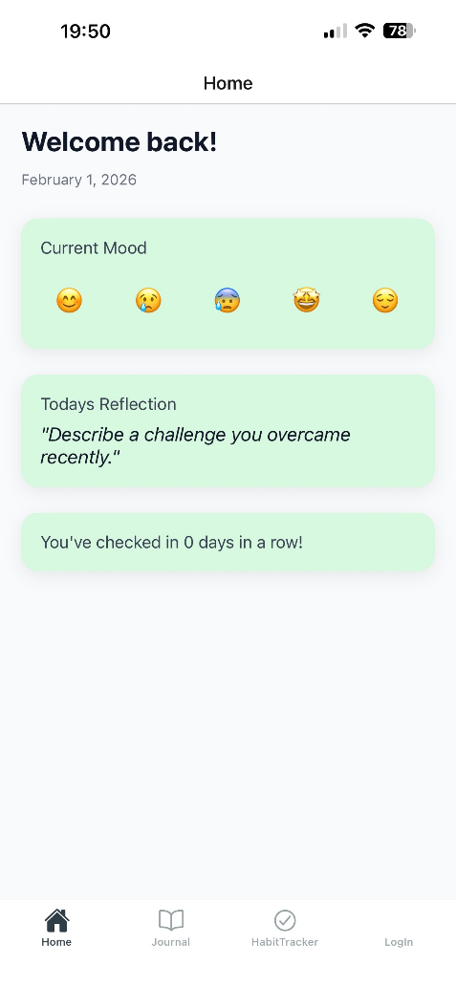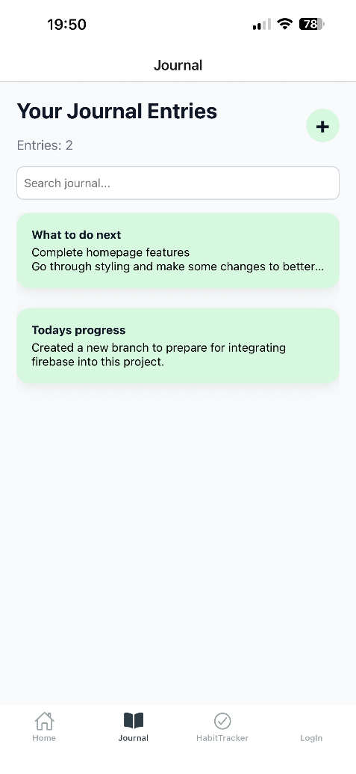
Issues / Blockers

No new issues.
Main blockers:

Next Steps

Create Testing code
Small adjustments (UI)

